Amazon Elastic Kubernetes Service (Amazon EKS)

Amazon Elastic Kubernetes Service (Amazon EKS) is a fully managed Kubernetes service. Customers such as Intel, Snap, Intuit, GoDaddy, and Autodesk trust EKS to run their most sensitive and mission critical applications because of its security, reliability, and scalability..

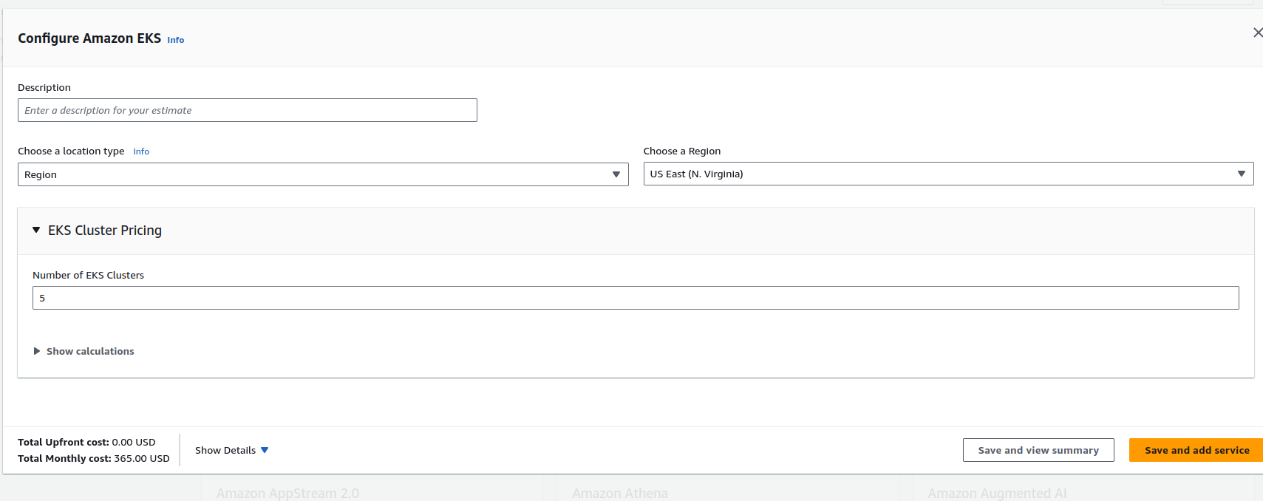
1 cluster = 73 USD
5 cluster = 73 * 5 = 365 USD


